Holiday Ornament Painting
The PTO is excited to host a holiday ornament painting event for students and their families! Come join us!

Date: Friday November 22, 2019

Time: 6:30pm-8:00pm

Location: Elementary School Cafeteria

RSVP: Form below due with payment by November 15, 2018

The price is $10 per ornament which includes kiln-firing, personalization of first name and year on each ornament, and a $5 coupon to Arts & Glass studio with each ornament. Parents are welcome to paint too! Ornaments will be available for pickup approximately 2 weeks after the event – just in time for the holidays!
Design options: 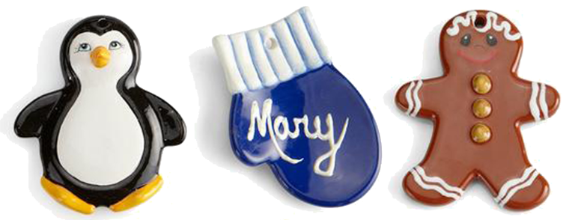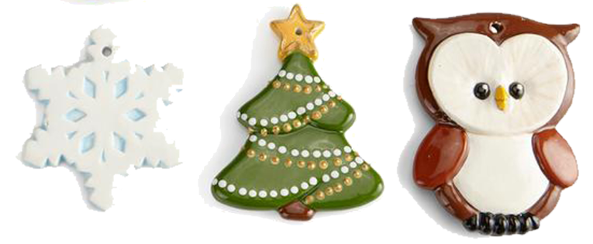
* Please choose which ornament you would like to paint or one will be chosen for you.
*Ornaments will be place on a table when you arrive for painting by last name.
*This year we will also have tables set up with a few local vendors with items for the children and parents to start their holiday shopping. IT IS NEVER TO EARLY TO SHOP! In addition, we will have a 50/50 raffle with 50% of the proceeds to go to the local food pantry. We will be collecting non-perishable items as well.

*All children must be accompanied by an adult.
------------------------------------------------------------------------------------------------------------------------------------------
Holiday Ornament Painting Sign-up Form
(Please return with payment by 11/15/18
Checks payable to Hoosic Valley PTO – thank you!)
Student’s name: _______________________________________________
Grade: ______________________________________________________
Teacher: _____________________________________________________
Number of ornaments: ________________ Design option_______________________

Parent’s email (for pickup notification): ____________________________________

Refreshments: If you are able to bring a refreshment to share, it would be much appreciated! Please check off one of the items below if you are able to provide something and we will follow up by email.

______Crackers & Cheese ______Veggies ______Fruit _____Cookies

__________Drinks _____Other - please specify:_____________________________
**Any questions regarding the above, or you would like to donate a basket for raffle or a new or gently used kids’ item (books, toys, puzzles, etc.) CONTACT: DARCY BEAULAC AT dbeaulac45@gmail.com. THANK YOU!!

